Creating Excitement for Data Exploration:
Students Using Data

Intended Audience  Students: Secondary Students | Intended Use  Data exploration starts with making predictions of what you will find in your data. Making predictions will spark curiosity and create excitement for looking at your data. Keep in mind that predictions are different from assumptions because predictions will be visible in your data!

Step 1: List Predictions | Step 2: List Underlying Assumptions | Step 3: Look at your results. What do they reveal?
Example: We predict that when we look at our results, we will see that we have a lower Sense of Belonging compared to the rest of Canada. | Example: We assume this because we hear our peers say that it is difficult to get involved in school activities because of lack of transportation home. | Example: Looking at the OurSCHOOL Sense of Belonging School results, we can see that our results have decreased by 17% since last year. Our results are also below replica school and national norm results.

Focus area | What do we think caused this result? | What additional data sources confirm this? | Action Plan Ideas
Example: Truancy rates increase in the upper grades.  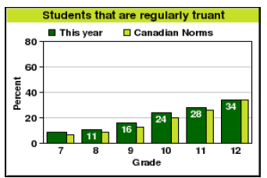 | Example: Students are leaving the school grounds during spare classes because there is not enough free study space for them to work. | Example: Student attendance records also show that there are poorer attendance in the upper grades. | Example: Designate the cafeteria as a quiet study zone during non-lunch hours so that students will have a place to study. This will encourage students to stay on school grounds.

