Practical Tips:

How to Generate Excitement for the OurSCHOOL Survey with Students

|  |  |
| --- | --- |
| Intended Audience  School and Division Staff | Intended Use  Have your students said that they are tired of completing the same survey year after year? Do you want to generate excitement for the survey? Are you looking for ideas of how to share results after the survey has been implemented? Try the following practical tips to generate excitement for the OurSCHOOL Survey and to help combat ‘survey fatigue.’  These tips can help to ensure that students see the value in the survey and view it as an opportunity to share their voice! Demonstrate to students that you are not just *collecting data to collect data* or to support reporting requirements. Let students know that they can be involved in the action plan, and that results from the survey will be used to help shape their school! Use this document to create a plan for generating excitement for the OurSCHOOL survey with students. |



Before You Survey

1. Communicate with students that the survey is coming up and what the purpose of the survey is. Use a variety of methods to share the message and be sure to indicate when the survey will be taking place and what will happen with the results.

|  |  |
| --- | --- |
| **Decide how to share the message...** | **Determine who will write and  share the message...** |
| * During homeroom * Using social media like Facebook or Twitter * During assemblies * School announcements * Student Council presentations * Special class presentations | * The principal * Teachers or support staff * Student Council * Students |

|  |  |
| --- | --- |
|  | *Resource |
| Try the [OurSCHOOL Presentation template](https://ourschool.thelearningbar.com/hc/en-ca/articles/115013073488) to communicate with your students. | |

**Sample Message:** *Attention Sunny Middle School students! Over the next two weeks, all students will have the chance to complete the OurSCHOOL survey. This survey will give all students a chance to provide thoughts and opinions about our school and how we can make it even better! Make sure you take your time and give your honest opinions because school staff will use information from the survey to help improve and make changes to our school.*

|  |
| --- |
| What’s Our Plan? |
| ***How will we share the message?*** |
|  |
| ***Who will write and share the message?*** |
|  |
| ***What will our message be?*** |
|  |

1. Be creative! Involve students in the planning process. Here are a few examples of ways schools have involved students before the survey:

* Ask students to develop questions that they want to be included in the survey. Let them know that the highest ranked questions will be included. This way, students can bring forward topics that they are interested in, and want to know more about. When the questions are finalized, have students make predictions on what their school results will be! They can even predict the results for each grade! Once the results are available, review them with students to see what the data shows!



|  |  |  |
| --- | --- | --- |
|  | *Resource | Find strategies for creating custom questions [here](https://ourschool.thelearningbar.com/hc/en-ca/articles/227868988-Creating-Custom-Questions-Strategies-for-Success). Need help getting started? [Click here](https://ourschool.thelearningbar.com/hc/en-ca/articles/360019619013-Sample-Custom-Questions-Multiple-Choice-Student-Survey-) to find a few examples of questions that others have asked. |

* Have students make and record their predictions and circle back once you have your results to see if they were right!  
  Our [Data Exploration worksheet](https://ourschool.thelearningbar.com/hc/en-ca/articles/360021184614-OurSCHOOL-Data-Worksheets-Students-Using-Data) can help you as you work with students.

* Create student survey teams that are responsible for the ‘set-up’ components of the survey. For example, one school developed a student team that was responsible for choosing the survey measures, custom questions, and promoting the survey to the student body. Keep in mind, student level of involvement can be customized to the context of your school.



*Watch: [See what grade 4 and 5 students can do with their data!](https://ourschool.thelearningbar.com/hc/en-ca/articles/115012657228-See-What-Grade-4-and-5-Students-Can-Do-with-Their-Data-video-)

|  |
| --- |
| What’s Our Plan? |
| ***How will we include students in the planning process?*** |
|  |

After You have Surveyed

1. Share results with students. You could choose to share specific results, or you could ask students to “find the story” in the data by looking at all results and noting what stands out to them. Here are a few ways schools have shared their results and plans with students:

In the classroom

*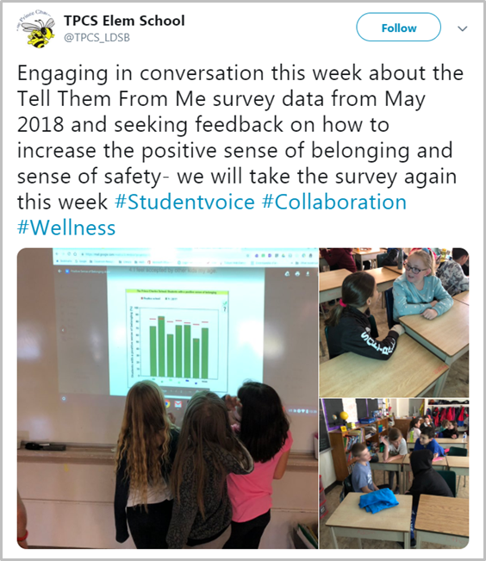For example:* You can include OurSCHOOL data in lesson plans.

During homeroom

*For example:* Share select school results with students and discuss students’ initial reactions.

Using social media like Facebook or Twitter

*For example:* Share areas to celebrate and areas for further improvement.

Posters on bulletin boards or notices on television screens

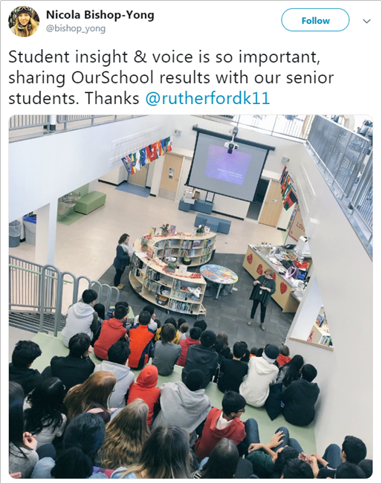*For example:* Create posters or notices with easy to interpret results to stimulate discussion among students and teachers in the hallways. You can also have a dedicated OurSCHOOL survey results wall where you post results for students and teachers to view.

During assemblies, school announcements, Student Council presentations, or special class presentations

*For example:* Have a student data team or school staff member share both the results, and what changes the school is going to make based on the results.

1. Organize a focus group to discuss the results of the survey with students. This is a great time to ask students about what actions or changes the school can make based on the results from the survey.

*Watch: [How to Prepare Staff, Students, and Parents for the Survey](https://ourschool.thelearningbar.com/hc/en-ca/articles/360019460594-How-to-Prepare-Staff-Students-and-Parents-for-the-Survey-video-)



|  |  |  |  |
| --- | --- | --- | --- |
|  | *Resource | No matter how you share the results with students, be sure to have and share an action plan with them as well.  For example, did students note that there is not enough promotion for school clubs? Let them know that you will be introducing a club promotion week to ensure all students know about the clubs that are offered.  The [We Asked, You Said Powerpoint Template](https://ourschool.thelearningbar.com/hc/en-ca/articles/227961448-Sample-PowerPoint-We-Asked-You-Said) is a great way to communicate survey results and school actions with students. |  |

|  |
| --- |
| What’s Our Plan? |
| ***How will we share results with students?*** |
|  |

Key Take-Aways

* Inform students and staff about when the survey will be taking place, and also the purpose of the survey.
* Involve students in the planning process.
* Help students make predictions.
* Share results with students and staff.
* Follow-up with focus groups to gather more information.
* Create a plan for action! What changes will you implement as a result of the survey?

***\*Resources:*** *All resources can be found on the Knowledge Base at* [*https://ourschool.thelearningbar.com/hc/en-ca*](https://ourschool.thelearningbar.com/hc/en-ca)