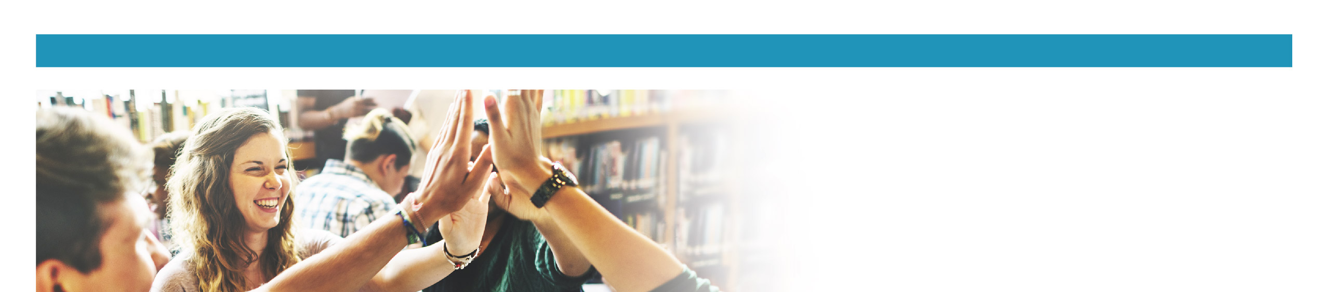

Survey Preparation: Terms and Definitions

This document contains definitions that may appear on the OurSCHOOL survey. You may choose to have this sheet on hand if students ask questions while they are completing the survey.

(S) - Applies to the Secondary Survey only
Accepted | Being liked the way you are; no need to change.
Bullying* | When a person tries to hurt another person and does it more than once. Bullying can be physical, verbal, or social, and can also take place over the internet with emails or text messages. The bully usually has power over the person being bullied, such as when the bully is bigger or more popular. Sometimes a group of students will bully others.  *Bullying is different than conflict. Conflict is having a disagreement or a different opinion than someone else. Conflict can be when two people get into a fight. It is not bullying unless it becomes negative, repeated over and over, and one person thinks they have more power over another person.
Challenged | To be faced with something that you think is difficult.
Disability | Describes any physical, mental, cognitive, or developmental condition that may limit a person’s ability to participate. A physical disability can include mobility, vision, or hearing impairments.
Discrimination (S) | Unfair treatment of someone. This could be because of their appearance, race, cultural background, religion or faith, gender identity, disability, etc.
Encourage | To make someone feel good about themselves, what they did, or what they want to do; to offer support.
Ethnic/Cultural Background | Your personal identity based on things like your culture, language, religion, physical appearance, or accent.
Feedback (S) | Information that can be used to improve something.
Gender Identity (S) | A person’s sense of their own gender; this can be whether you see yourself as a boy or as a girl, regardless of the sex you were assigned at birth. This is not related to sexual orientation (whether you like boys or whether you like girls).
Inappropriate (S) | Something that is not acceptable (e.g. those are not proper shoes for gym).
Inclusive (S) | To be accepting of everyone, no matter what they look like, how they feel, or what they can or cannot do.
Meaningful | Something important or worthwhile. For example – ‘We explore topics that are meaningful’ means – we explore topics that are important, worthwhile, and useful.
Nervous | Worried.
Sad or depressed (S) | Feelings of sadness for more than two weeks in a row. These would be periods of depression or deep sadness, not simply feeling sad which is normal every once in a while.
Sexual harassment (S) | Sexual harassment is any unwanted sexual remarks, sexual jokes, or sexual touching that makes you feel upset, hurt, or angry.
Sexual orientation (S) | Refers to who you are attracted to and who you choose to be in relationships with. For example – ‘Have you been mistreated because of your sexual orientation’ means - have you been made fun of because you are attracted to girls, or attracted to boys, or attracted to both?
Statement | A sentence or phrase.
Strategies | Plans or actions that help achieve a goal.
Threat, threaten | Someone scaring you by saying they will do something bad.

Please note: There may be additional terms that you feel need to be reviewed with students. Click here to see how you can access the survey questions in advance of the survey.

